**Assignment1**

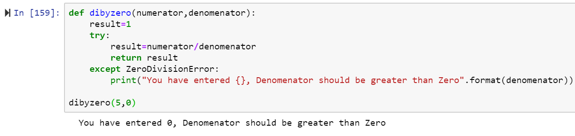

**Assignment2**

